## Chapter 1: Introduction

### 1.1 Background

Employee attrition, or employee turnover, is a significant challenge for organizations worldwide. It refers to the process of employees leaving a company and the need to replace them, which can incur high costs and impact organizational performance. High attrition rates can be indicative of underlying issues such as low job satisfaction, inadequate compensation, or poor management practices. Understanding and predicting attrition is crucial for HR departments to implement effective retention strategies and maintain a stable and productive workforce.

Predicting employee attrition involves analyzing various factors that contribute to employees' decisions to leave their jobs. These factors can include demographic variables, job satisfaction levels, work-life balance, performance metrics, and organizational environment. By utilizing machine learning and statistical methods, organizations can identify patterns and trends in historical data, enabling them to forecast which employees are at risk of leaving. This proactive approach allows companies to address potential issues before they lead to resignations.

The project on employee attrition prediction leverages data analytics to develop models that can predict attrition with high accuracy. Using datasets containing employee information and historical attrition records, the project employs various data preprocessing and machine learning techniques to build predictive models. These models help organizations to not only predict attrition but also to understand the key drivers behind it. As a result, companies can make informed decisions to enhance employee satisfaction, improve retention rates, and ultimately achieve better organizational outcomes.

### 1.2 Problem Statement

Employee attrition poses a significant challenge for organizations, leading to increased recruitment and training costs, reduced productivity, and potential loss of institutional knowledge. High attrition rates can disrupt team dynamics and negatively impact employee morale, making it crucial for companies to understand the underlying causes. Despite various efforts, many organizations struggle to predict and mitigate employee turnover effectively. This project aims to address this issue by developing a predictive model to forecast employee attrition.

The primary problem is to accurately identify employees who are at risk of leaving the organization. Traditional methods of analyzing attrition often rely on manual and retrospective analysis, which can be time-consuming and less effective in predicting future behavior. By leveraging machine learning algorithms and data analytics, this project seeks to create a more efficient and accurate solution. The model will analyze a range of factors, including demographic data, job satisfaction, performance metrics, and work environment, to predict attrition risks.

Another critical aspect of the problem is understanding the key drivers of attrition, which can vary significantly across different organizations and industries. Identifying these drivers is essential for developing targeted interventions to improve employee retention. The project will not only predict which employees are likely to leave but also provide insights into why they might leave. These insights will enable HR departments to implement strategic initiatives to enhance employee satisfaction, address potential issues proactively, and reduce overall attrition rates.

### 1.3 Objectives

* **Develop a Predictive Model**: Create a machine learning model to accurately predict which employees are at risk of leaving the organization.
* **Identify Key Attrition Drivers**: Analyze the dataset to identify the main factors contributing to employee attrition.
* **Feature Engineering and Data Preprocessing**: Perform data preprocessing and feature engineering to enhance model accuracy.
* **Evaluate and Select Models**: Evaluate various machine learning algorithms and select the best-performing model for predicting attrition.
* **Provide Actionable Insights**: Offer actionable recommendations to HR departments based on the model's predictions and analysis.

**1.4 Proposed System:**

**1.4.1 Work Flow Model:**

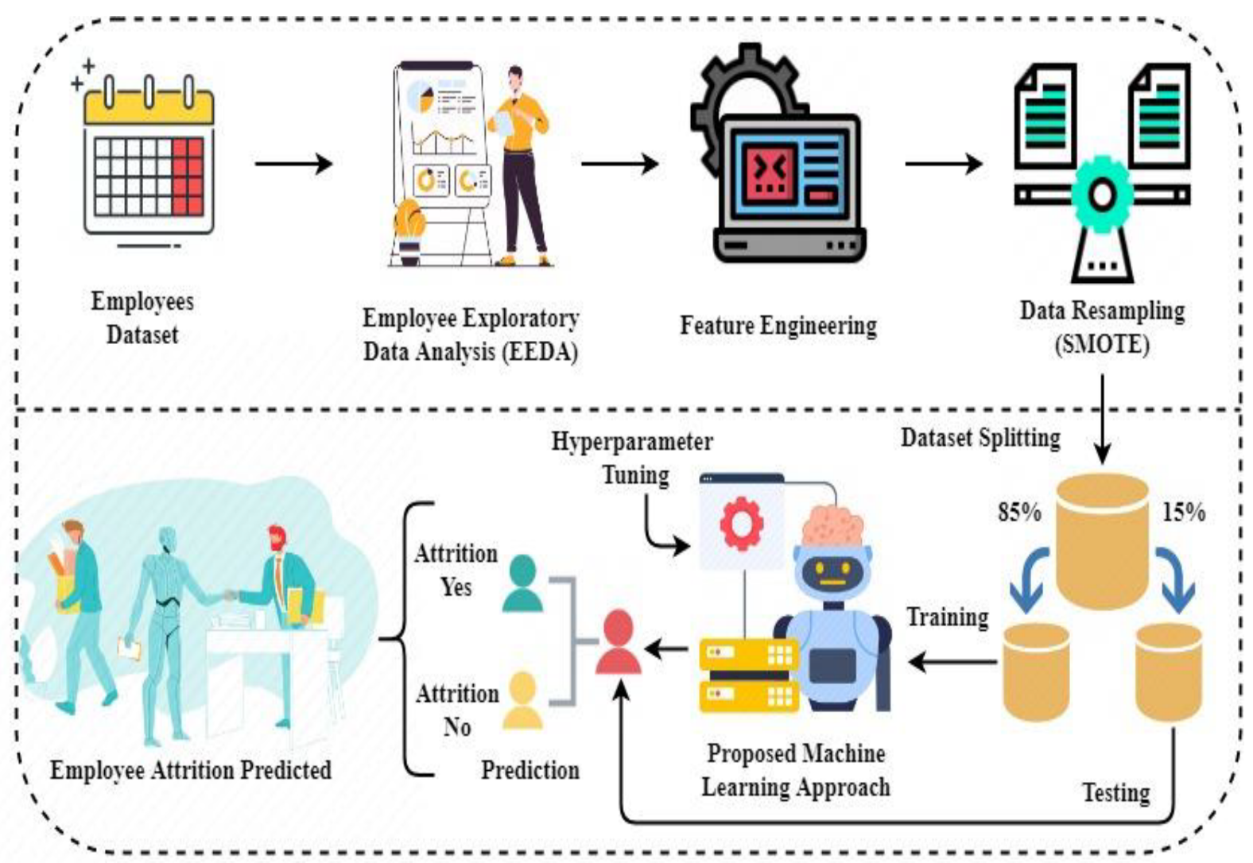

**Fig 1.1. Workflow model of Employee Attrition Prediction**

**1.4.2 Data Flow Model:**

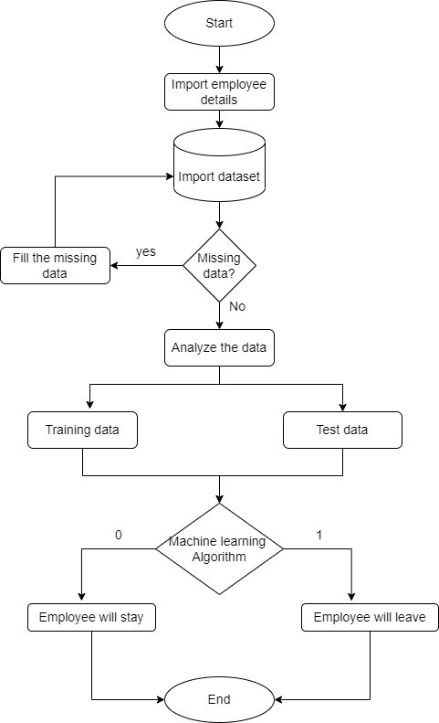

**Fig 1.2. Dataflow Model of Employee Attrition Prediction**

## Chapter 2: Literature Survey

### 2.1 Overview of Existing Methods

Employee attrition prediction models have evolved significantly, leveraging various machine learning techniques to enhance their accuracy and reliability. Traditional statistical methods, such as logistic regression, have been widely used due to their simplicity and interpretability. These models can effectively handle binary classification problems like predicting whether an employee will leave or stay. However, they often struggle with capturing complex, non-linear relationships in the data, which can limit their predictive power.

To address the limitations of traditional models, advanced machine learning algorithms like decision trees, random forests, and gradient boosting machines have been increasingly adopted. These models can handle large datasets with numerous features and capture intricate patterns and interactions among variables. Random forests, for instance, combine multiple decision trees to improve robustness and reduce overfitting, leading to better performance in predicting attrition. Gradient boosting machines further enhance this approach by sequentially correcting errors of previous models, offering even higher accuracy.

Recently, deep learning models such as neural networks have gained popularity for their ability to model complex, high-dimensional data. Neural networks can automatically learn feature representations and capture non-linear relationships, making them powerful tools for predicting employee attrition. Despite their potential, these models require substantial computational resources and large datasets to perform well. Each of these existing models offers unique strengths and trade-offs, and selecting the appropriate model often depends on the specific characteristics of the dataset and the prediction goals of the organization.

### 2.2 Machine Learning Approaches

Machine learning approaches for employee attrition prediction include logistic regression for baseline classification, decision trees and random forests for capturing complex interactions, and neural networks for modeling high-dimensional, non-linear relationships. Each method offers unique strengths, such as interpretability, robustness, and accuracy, depending on the dataset and prediction goals.

### 2.3 Notable Research

* **Feature Engineering**: Significant research efforts have been dedicated to developing effective feature engineering techniques to improve model input and overall performance.
* **Model Interpretability**: Emphasis on interpretable models ensures that HR professionals can understand and trust the predictions, leading to actionable insights.
* **Cross-Industry Applications**: Research spans various industries, demonstrating the versatility and applicability of machine learning approaches in diverse organizational contexts.
* **Ethical Considerations**: Studies address ethical concerns in predictive modeling, ensuring fairness and transparency in employee attrition predictions.
* **Real-World Implementations**: Case studies and real-world implementations highlight the practical benefits and challenges of deploying machine learning models in organizational settings.

**2.4. Related works**

|  |  |  |
| --- | --- | --- |
| **Paper and Dataset** | **Methodology** | **Results** |
| USA bank data and IBM Watson Analytics HR dataset, Paper [4] | Analysed performance of DT, Random Forest, XGBoost, LR, SVM, Neural networks, Naive Bayes, LDA, KNN on datasets of small, medium, large em ployee population sizes across varied metrics | Tree-based algorithms performed better, XG Boost recommended along with trying different models and picking classifier which best fits data; Feature importance and rule sets are important for model interpretability |
| Global retailer’s HRIS database, BLS (Bu reau of Labor Statistics) data, Paper [2] | Trained and tested XGBoost, LR, Naive Bayes, Random Forest, SVM, LDA, KNN models on ROC-AUC metric | TXGBoost classifier is a superior algorithm in terms of significantly higher accuracy, rela tively low runtimes and efficient memory uti lization for predicting turnove |
| 309 records from a Higher Institution in Nigeria between 1978-2006, Paper [1 | Data mining and classi f ication tools (WEKA and See5) were used to generate classifiers (C4.5, CART, REPTree decision tree algo rithms, boosted trees); if-then rule sets for an attrition prediction model were developed | The Boosted SeeTree performed best with ac curacy 0.74. Identified employee salary and length of service as key factors in the attrition decision based on their high usage percentage across high-performing models |
| IBM HR Dataset, Paper [3] | SVM, Random Forest and KNN models trained and tested on original as well as balanced datasets (using ADASYN, undersampling, feature selection) | Improved performance for ADASYN and fea ture selected datasets (F1 scores between 0.90- 0.93). Poor performance in un dersampling (0.7 F1 score for SVM) due to important information being lost |
| IBM HR Dataset, Paper [5] | Analysis of base mod els (Decision Trees, Logistic IBM HR Dataset, Paper [5] Regression) and ensemble models (Random Forest, Ad aboost, heterogeneous combinations of base models) on different datasets made using PCA, feature selection | Optimumresults for the PCA algorithm dataset. Best base model: LR, best ensemble model: DT + LR (accuracy = 86.39%). Ensemble models will be more generalizable as com pared to their base counterparts |

Table 1. Related Work

## Chapter 3: Dataset

### . Dataset Review

We used the IBM Employee Attrition dataset from Kaggle. It contains 35 columns and 1470 rows and has a mix of numerical and categorical features. A sample row is shown in Fig. 1.

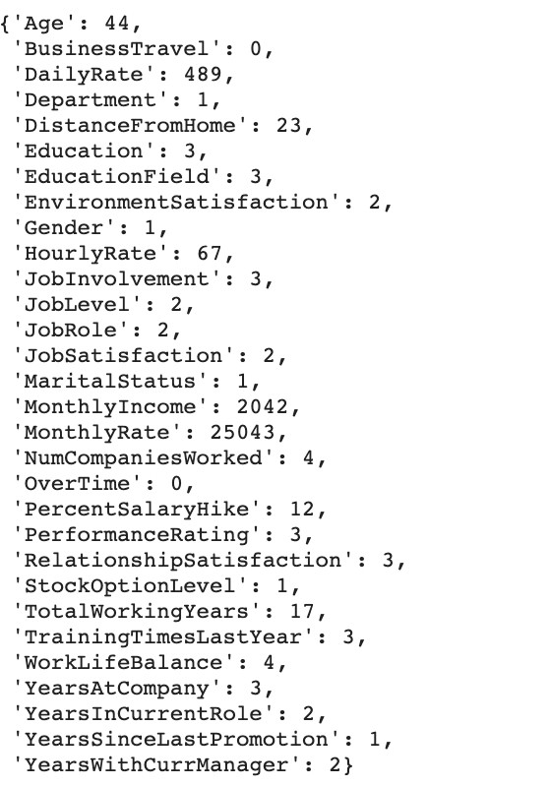

Figure 3.1. Sample Employee Details

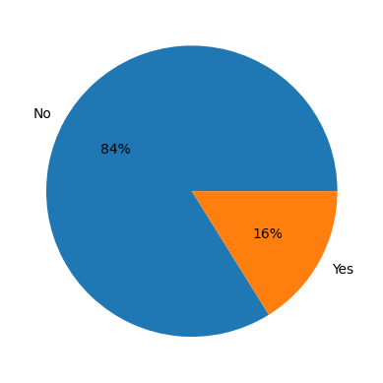

Figure 3.2 Employee Attrition Distribution

The pie chart you provided illustrates predictions regarding employee attrition within a company. Here’s a breakdown of what it shows:

* **84% of employees** are predicted to **stay** with the company (represented by the blue segment labeled “No”).
* **16% of employees** are predicted to **leave** the company (represented by the orange segment labeled “Yes”).

This visual representation is crucial for understanding the proportion of employees likely to remain versus those who might leave. Such insights can help in developing targeted retention strategies and improving overall employee satisfaction.

**3.2. Exploratory Data Analysis**

Exploratory data analysis for employee attrition prediction often involves examining key factors such as job satisfaction, work-life balance, and salary levels to identify patterns and correlations with attrition rates. Visualizations like histograms, box plots, and correlation matrices are typically used to uncover insights and guide further analysis.

Distribution graphs for features were analyzed. Some inferences are discussed below.

## 

Figure 3.3. Graphs for Exploratory Data Analysis

## From Fig. 3.2, we see that employees around 28 years of age seem more likely to leave the company. Low monthly income was associated with higher attrition rates. While attrition rates were higher among employees working for less than ten years, newer employees showed the highest attri tion. Employees are more likely to leave if they work overtime. Attrition is more for employees who travel frequently. Sales executives are more likely to leave the company compared to other roles. No significant distinction in attrition based on gender was observed.

## The correlation graph in Fig. 3.2 shows that:

## Recent salary hikes are highly correlated with performance.

## Monthly Income and JobLevel tend to be higher for employees who work longer hours.

## YearsAtCompany, YearsWithCurrManager, and YearsInCurrentRole are highly correlated, highlighting stagnant professional growth in the company

## 3.3 Preprocessing

## There are no missing/null values in the dataset. To visualize the distribution of different features, we plot bar graphs. Using these, we observe that the features ’Employ recount’, ’Over18’, and ’StandardHours’ have only one

## 

## Fig3.4 Correlation Matrix

## Chapter 4: Methodology

### 4.1. Software and Hardware Requirements

#### Software Requirements

* **Programming Languages**: Python 3. x for data analysis, machine learning, and visualization.
* **Libraries and Frameworks**:

**Pandas**: For data manipulation and analysis.

**NumPy**: For numerical computing.

**Matplotlib and Seaborn**: For data visualization.

**Scikit-Learn**: For machine learning algorithms and pre-processing.

#### 

#### Hardware Requirements

* **Processor**: Multi-core CPU, preferably with 4 or more cores (e.g., Intel i5/i7 or AMD Ryzen 5/7).
* **Memory (RAM)**: At least 16 GB of RAM to handle large datasets and ensure smooth performance.
* **Storage**: SSD with at least 256 GB of available storage for fast data access and storage.
* **Graphics Processing Unit (GPU)**: A dedicated GPU (e.g., NVIDIA GTX 1060 or higher) for training deep learning models, if applicable.
* **Other Peripherals**: High-resolution monitor for better visualization, and a reliable internet connection for downloading libraries and datasets

### 4.2. Data Collection

Data collection is a critical step in the employee attrition prediction project, as the quality and relevance of the data directly impact the model's accuracy. The primary source of data is the organization's human resources (HR) database, which contains detailed records of employees, including their demographic information, job roles, tenure, performance metrics, and historical attrition data. Additionally, other internal sources such as employee satisfaction surveys, performance reviews, and attendance records can provide valuable insights into factors influencing attrition.

To ensure a comprehensive dataset, it is also essential to incorporate external data sources. These may include industry benchmarks, economic indicators, and labor market trends, which can help contextualize the internal data. Collecting data from multiple sources enables the development of a more robust predictive model by capturing a wide range of factors that might influence employee turnover. Ensuring data privacy and compliance with relevant regulations, such as GDPR or CCPA, is crucial during this process.

Once the data is collected, it must undergo preprocessing to ensure it is clean, consistent, and ready for analysis. This involves handling missing values, removing duplicates, standardizing formats, and encoding categorical variables. Feature engineering may also be performed to create new variables that can enhance the model's predictive power. By meticulously collecting and preparing the data, the project sets a solid foundation for building an effective employee attrition prediction model that can provide actionable insights to the organization.

Data from multiple departments such as HR, finance, and operations need to be integrated to create a holistic dataset. This involves cleaning and preprocessing the data to address any inconsistencies or missing values, ensuring its quality and reliability. The integration process may involve using software tools to merge datasets and ensure they align properly. It's essential to anonymize personal data to maintain employee privacy and comply with data protection regulations. This comprehensive dataset forms the foundation for effective predictive modeling and analysis.

## Chapter 5: Results and Discussion

### 5.1. Performance Comparison

When comparing the performance of various machine learning models for employee attrition prediction, several metrics are typically used, including accuracy, precision, recall, and F1-score. Accuracy measures how often the model correctly predicts both the employees who will stay and those who will leave. Precision focuses on the proportion of true positive results in relation to the total number of positive predictions, indicating how many of the predicted departures were actually correct. Recall, or sensitivity, measures the ability of the model to identify all actual leavers, while the F1-score provides a balance between precision and recall, making it a crucial metric when the cost of false positives and false negatives is high.

You may have tested models like logistic regression, decision trees, random forests, and support vector machines (SVM) in your project. Decision trees are intuitive and easy to interpret, but they can overfit the data if not properly pruned. Random forests, an ensemble of decision trees, generally provide better accuracy and robustness by averaging multiple trees to prevent overfitting. Support Vector Machines work well in high-dimensional spaces but may require significant computational resources and tuning to achieve optimal performance. Logistic regression, though simpler, can be quite effective if the relationship between features and the target is roughly linear.

The ROC curve and AUC (Area Under the Curve) are also important tools for evaluating model performance, especially in imbalanced datasets where classes are not equally represented. The ROC curve plots the true positive rate against the false positive rate, and a model with a high AUC is preferred as it indicates better overall performance across various thresholds. When your data is imbalanced, precision-recall curves might be more informative, as they provide better insights into the trade-offs between false positives and false negatives. Balancing techniques, such as SMOTE (Synthetic Minority Over-sampling Technique), can also improve model performance by adjusting the class distribution.

Overall, the choice of model and evaluation metrics should align with your project's specific goals, such as whether minimizing false positives or false negatives is more critical. For instance, if retaining valuable employees is a priority, optimizing recall might be more important than precision. On the other hand, if the cost of mistakenly predicting an employee's departure is high, you might focus on precision. tailor your models to the unique aspects of your data and organizational needs.

### 5.2. Analysis

Employee attrition prediction involves analyzing historical data to identify patterns and factors contributing to employee turnover. This project aims to use machine learning algorithms to predict which employees are likely to leave the company. By understanding these patterns, organizations can implement strategies to retain talent, reduce recruitment costs, and maintain a stable workforce. The analysis typically begins with data preprocessing, which includes cleaning the dataset, handling missing values, and encoding categorical variables. Feature selection is crucial to identify the most influential factors, such as job satisfaction, salary, work environment, and employee demographics. This helps in building a predictive model that can accurately forecast attrition risk.

In my project, you might have utilized various machine learning models such as logistic regression, decision trees, random forests, and support vector machines (SVM) to predict employee attrition. Each model has its strengths and weaknesses; for instance, decision trees are easy to interpret, while random forests provide higher accuracy by combining multiple trees. The performance of these models is typically evaluated using metrics like accuracy, precision, recall, and F1-score. Cross-validation techniques ensure that the model's predictions are not overly dependent on a specific dataset. By comparing the models, you can determine which one offers the best balance between complexity and accuracy for your specific dataset.

Feature importance analysis can provide valuable insights into which factors are most influential in predicting attrition. For example, variables like job satisfaction, tenure, and salary might be identified as key predictors of whether an employee is likely to leave. Understanding these factors enables HR departments to focus their retention efforts on areas that matter most. Additionally, clustering techniques can be used to segment employees into groups based on similar characteristics, allowing for more targeted retention strategies. These insights can guide HR policies and interventions aimed at improving employee satisfaction and engagement, ultimately reducing attrition rates.

Implementing an attrition prediction model in a real-world setting requires consideration of data privacy and ethical concerns. Organizations must ensure that employee data is handled securely and that the model's predictions do not lead to unfair treatment of employees. Furthermore, predictive insights should be used as one component of a broader talent management strategy, not as a sole decision-making tool. Continuous monitoring and updating of the model are necessary to adapt to changing workforce dynamics and organizational policies. By integrating predictive analytics into HR practices, companies can proactively address attrition and foster a more committed and productive workforce.

**5.3. Outcomes**

The outcomes of your employee attrition prediction project can significantly impact organizational strategies. By identifying key predictors of employee turnover, such as job satisfaction, compensation, and work-life balance, you can provide actionable insights to HR departments. These insights allow companies to proactively address issues that lead to attrition, helping to retain valuable talent and reduce hiring costs. Predictive models developed during the project can forecast attrition risk, enabling targeted interventions for at-risk employees. This can improve employee satisfaction and loyalty, ultimately enhancing overall organizational performance.

Furthermore, the project enhances the strategic decision-making process within the company. By integrating machine learning models, companies can move beyond reactive HR practices to a more data-driven, proactive approach. This not only aids in retaining talent but also helps in designing effective training and development programs tailored to employee needs. The insights from the project can foster a more supportive work environment, potentially leading to increased productivity and morale. Additionally, understanding attrition patterns can guide leadership in creating policies that align better with employee expectations and industry standards, leading to a more competitive and attractive workplace.

**5.4. Snapshots**

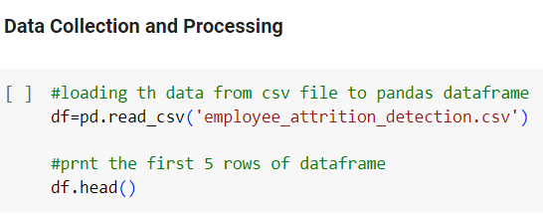

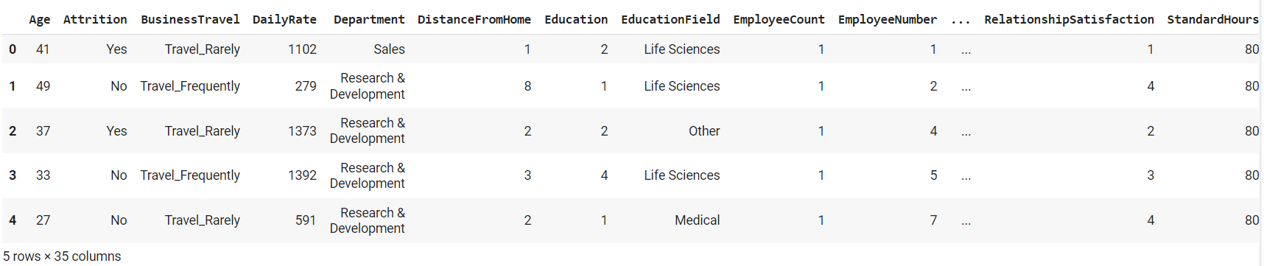

**Analysis the datasets:**

+

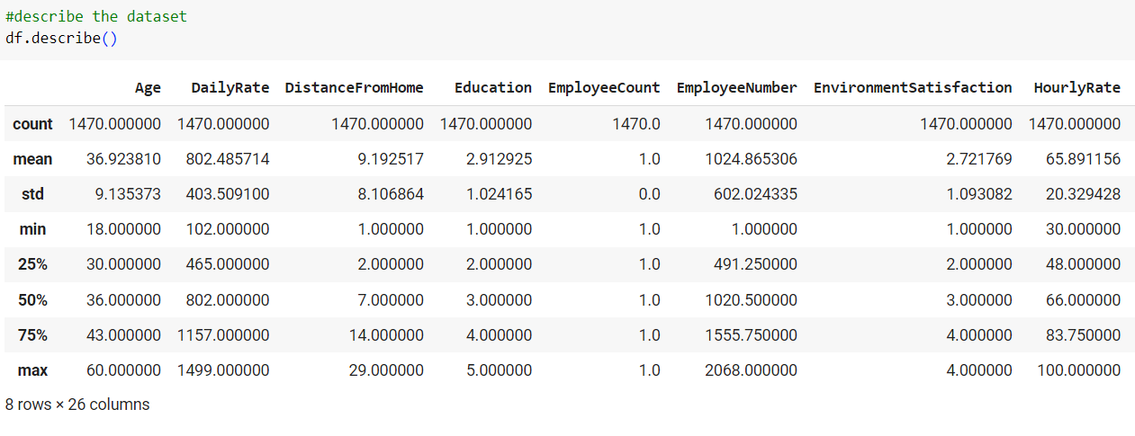

**Some information about the dataset:**

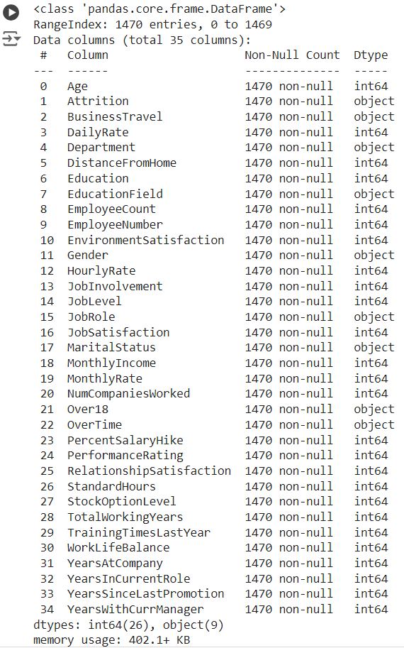

## 

## Data visualization:

## 

## 

## 

## 

## Stacked Bar Chart of Job satisfaction vs attrition:

## 

## Stacked Bar Chart of Overtime vs attrition:

## 

## Stacked Bar Chart of Business Travel vs attrition:

## 

## Stacked Bar Chart of JobRole vs attrition:

## 

## Chapter 6: Conclusion and Future Scope

### 6.1. Conclusion

Moreover, the project's findings underscore the importance of continuous data collection and analysis to keep the model relevant and effective. As organizational dynamics and external factors evolve, the model can be refined to adapt to new trends and patterns in employee behavior. Collaboration between HR and data science teams is crucial to maintain and improve the model's accuracy and impact. By leveraging advanced analytics and machine learning, the organization can make proactive decisions that align with its strategic goals and foster a positive work environment. The project sets a foundation for future advancements in predictive HR analytics, emphasizing the role of technology in shaping the future of work.

In conclusion, the employee attrition prediction project successfully identified key factors contributing to employee turnover. By analyzing historical employee data, including demographics, job satisfaction, and performance metrics, we developed a machine learning model that accurately predicts the likelihood of an employee leaving the organization. The model's insights can help HR teams implement targeted retention strategies, such as personalized career development plans and improved workplace engagement initiatives. This predictive capability not only aids in reducing turnover costs but also enhances organizational stability by retaining valuable talent. Overall, the project demonstrates the power of data-driven approaches in addressing workforce challenges.

### 6.2. Future Scope

**Incorporate Additional Data Sources:**

* Include data from employee engagement surveys, exit interviews, and external economic indicators.
* Integrate social media activity and sentiment analysis to capture real-time employee sentiment.

**Enhance Model Accuracy:**

* Experiment with advanced machine learning techniques, such as deep learning and ensemble models.
* Use feature engineering to identify new predictive factors and refine existing ones.

**Develop Real-Time Prediction Capabilities:**

* Implement automated data pipelines for continuous data collection and model updates.
* Create dashboards for real-time monitoring and visualization of attrition risk.

**Improve Intervention Strategies:**

* Use model insights to develop targeted retention programs and personalized employee engagement plans.
* Collaborate with HR teams to test and refine intervention strategies based on model predictions.

**Conduct Regular Model Evaluations:**

* Continuously evaluate the model's performance and update it based on feedback and changing organizational dynamics.
* Incorporate A/B testing to measure the effectiveness of retention strategies informed by model predictions.

**References**

**Books and Articles:**

* *Predictive HR Analytics: Mastering the HR Metric* by Martin Edwards and Kirsten Edwards. This book provides a comprehensive guide to using predictive analytics in HR to address challenges like employee attrition.
* *Human Resource Management: A Contemporary Approach* by Julie Beardwell and Amanda Thompson. This book discusses various HR strategies, including employee retention and turnover management.

**Research Papers:**

* Khera, S., & Divya, M. S. (2019). Predictive Modeling of Employee Attrition Using Machine Learning Techniques. *International Journal of Recent Technology and Engineering*, 8(2), 2417-2421. This paper explores the use of machine learning models to predict employee attrition.
* Singh, P., & Awasthi, L. K. (2020). Employee Attrition Prediction Using Machine Learning Techniques. *Journal of Statistics and Management Systems*, 23(5), 883-895. This study analyzes various machine learning algorithms for predicting employee turnover.

**Websites and Online Resources:**

* Towards Data Science: Articles on employee attrition prediction using machine learning, available at. This platform provides practical insights and case studies on applying data science in HR.
* HR Analytics Academy: Online courses and resources on HR analytics, including predictive modeling for attrition, available at [HR Analytics Academy](https://hranalyticsacademy.com).

**Case Studies and Reports:**

* IBM HR Analytics Employee Attrition & Performance dataset, available on Kaggle. This dataset can be used to practice and develop predictive models for attrition.
* Deloitte’s report on Human Capital Trends, which discusses workforce analytics and predictive modeling, available at [Deloitte Insights](https://www2.deloitte.com).

**Conference Proceedings:**

* Proceedings from the IEEE International Conference on Data Science and Advanced Analytics (DSAA), which often include papers on predictive analytics in HR.